CUSTOMER CHURN PREDICTION
A Machine Learning Case Study for Nigerian Fintech

Prepared by: Ayodeji Toluwani
AI / Data Intern — NCAIR
ayodejitoluwani@gmail.com | LinkedIn
March 2026

EXECUTIVE SUMMARY
Customer churn is one of the most costly challenges facing Nigerian fintech companies. Losing a customer means losing not just their current balance, but future transactions, referrals, and lifetime value. This report presents a data-driven approach to identifying which customers are most at risk of churning — and why.

Using a simulated dataset of 1,000 fintech customers, we conducted exploratory data analysis, identified key churn drivers, and built two machine learning models — Logistic Regression and Decision Tree — to predict churn risk. Our best model achieved 89% accuracy and an AUC score of 0.948, meaning it correctly ranks churners above non-churners 94.8% of the time.

1,000  Customers Analysed | 12.0%  Churn Rate | 89.0%  Best Model Accuracy | 0.948  Best AUC Score

1. PROBLEM STATEMENT
In a competitive fintech market, retaining customers is significantly cheaper than acquiring new ones. Industry research suggests that a 5% reduction in churn can increase profitability by 25–95%. Despite this, most fintech companies react to churn after it happens, rather than predicting and preventing it.

This project addresses the following question:

"Can we predict which customers are likely to churn before they do, and identify the key factors driving that risk?"

Answering this enables a fintech company to:
- Proactively reach out to at-risk customers with retention offers
- Prioritise high-value customers for intervention
- Optimise product features that drive engagement and reduce churn
2. DATASET OVERVIEW
The dataset contains 1,000 Nigerian fintech customer records with 13 features covering demographics, account behaviour, product usage, and engagement metrics. Key variables include:

- Demographics: Age, State of residence
- Account profile: Account type (Basic, Premium, Business), tenure in months
- Transaction behaviour: Monthly transactions, average transaction value (NGN), account balance
- Product engagement: Savings plan status, loan uptake, app logins per month
- Support signals: Number of customer support calls, referrals made
- Target variable: Churned (1 = churned, 0 = retained)

The overall churn rate in the dataset is 12%, reflecting a realistic scenario for an early-to-mid stage Nigerian fintech.
3. EXPLORATORY DATA ANALYSIS
3.1 Churn Overview
12% of customers churned during the observed period. Churn varied significantly across account types and geographies, with Basic account holders and certain states showing elevated risk.
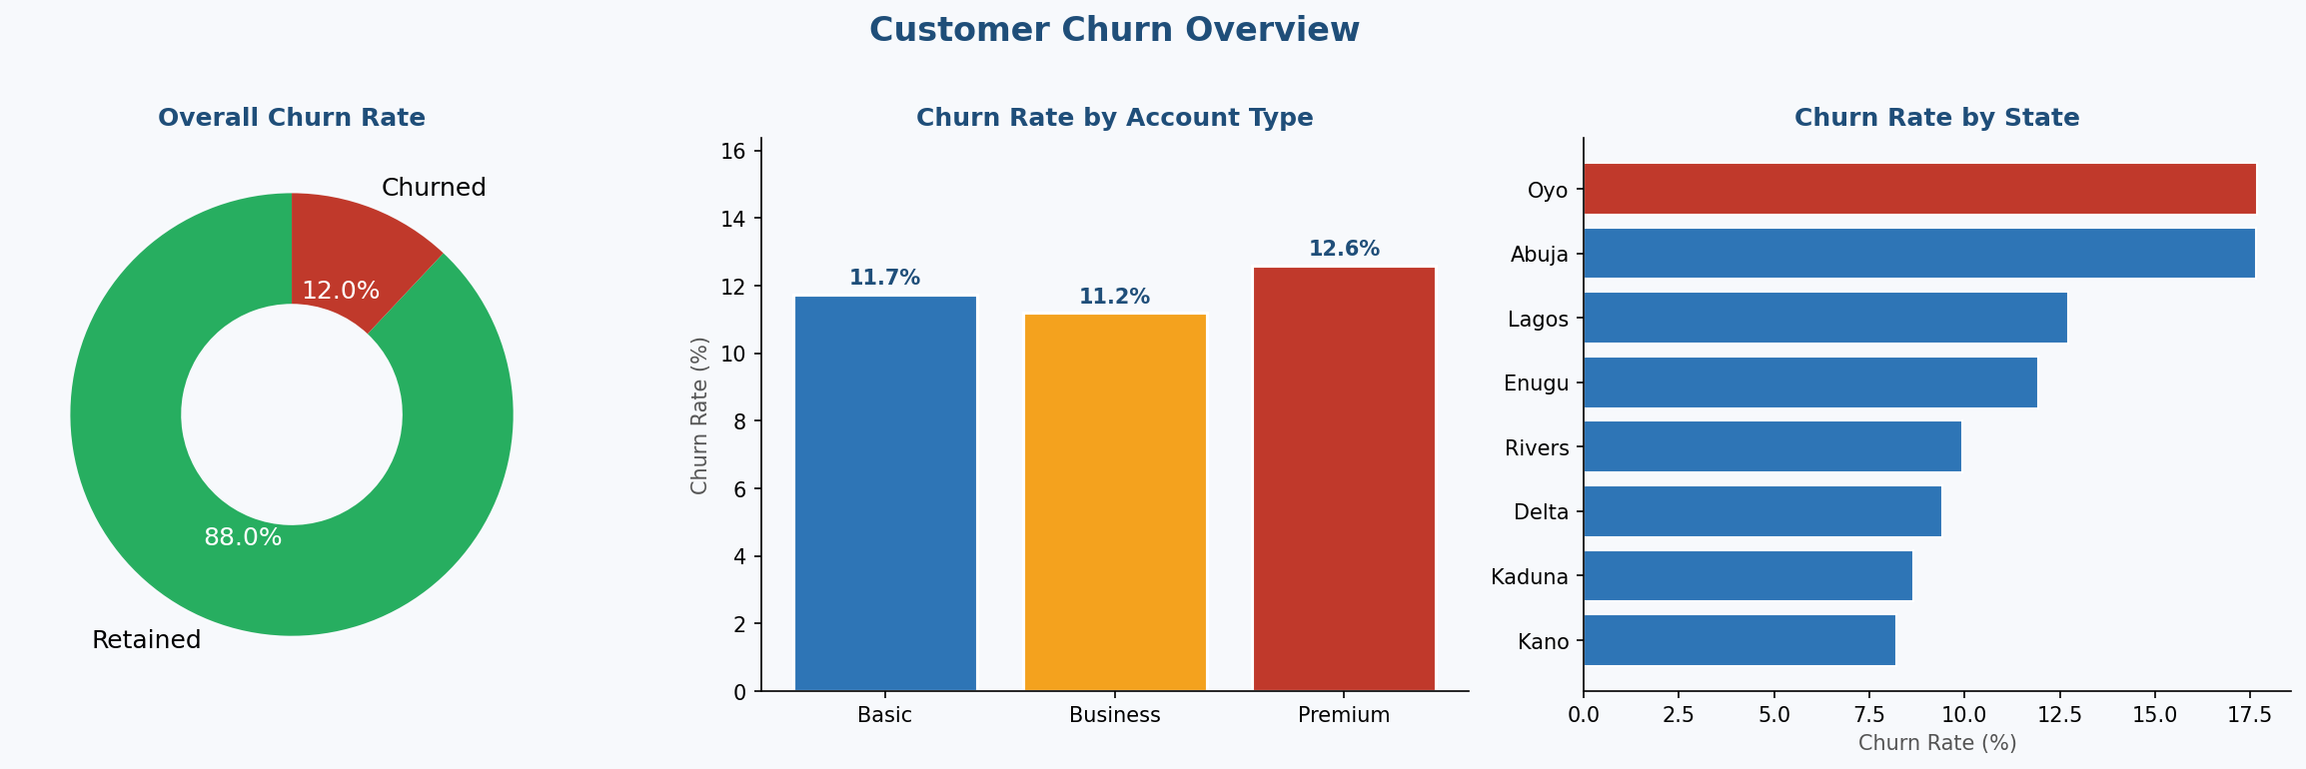
3.2 Key Churn Drivers
Analysis of individual features revealed four strong churn predictors:

- Tenure: Newer customers churn at significantly higher rates. Customers who have been on the platform for less than 6 months are the most vulnerable — suggesting onboarding experience is critical.
- Customer Support Calls: Churned customers made substantially more support calls on average, indicating unresolved frustrations as a leading churn signal.
- App Engagement: Customers with lower monthly app logins showed higher churn, confirming that low engagement precedes departure.
- Savings Plan: Customers with an active savings plan churned far less frequently — product stickiness is a key retention mechanism.
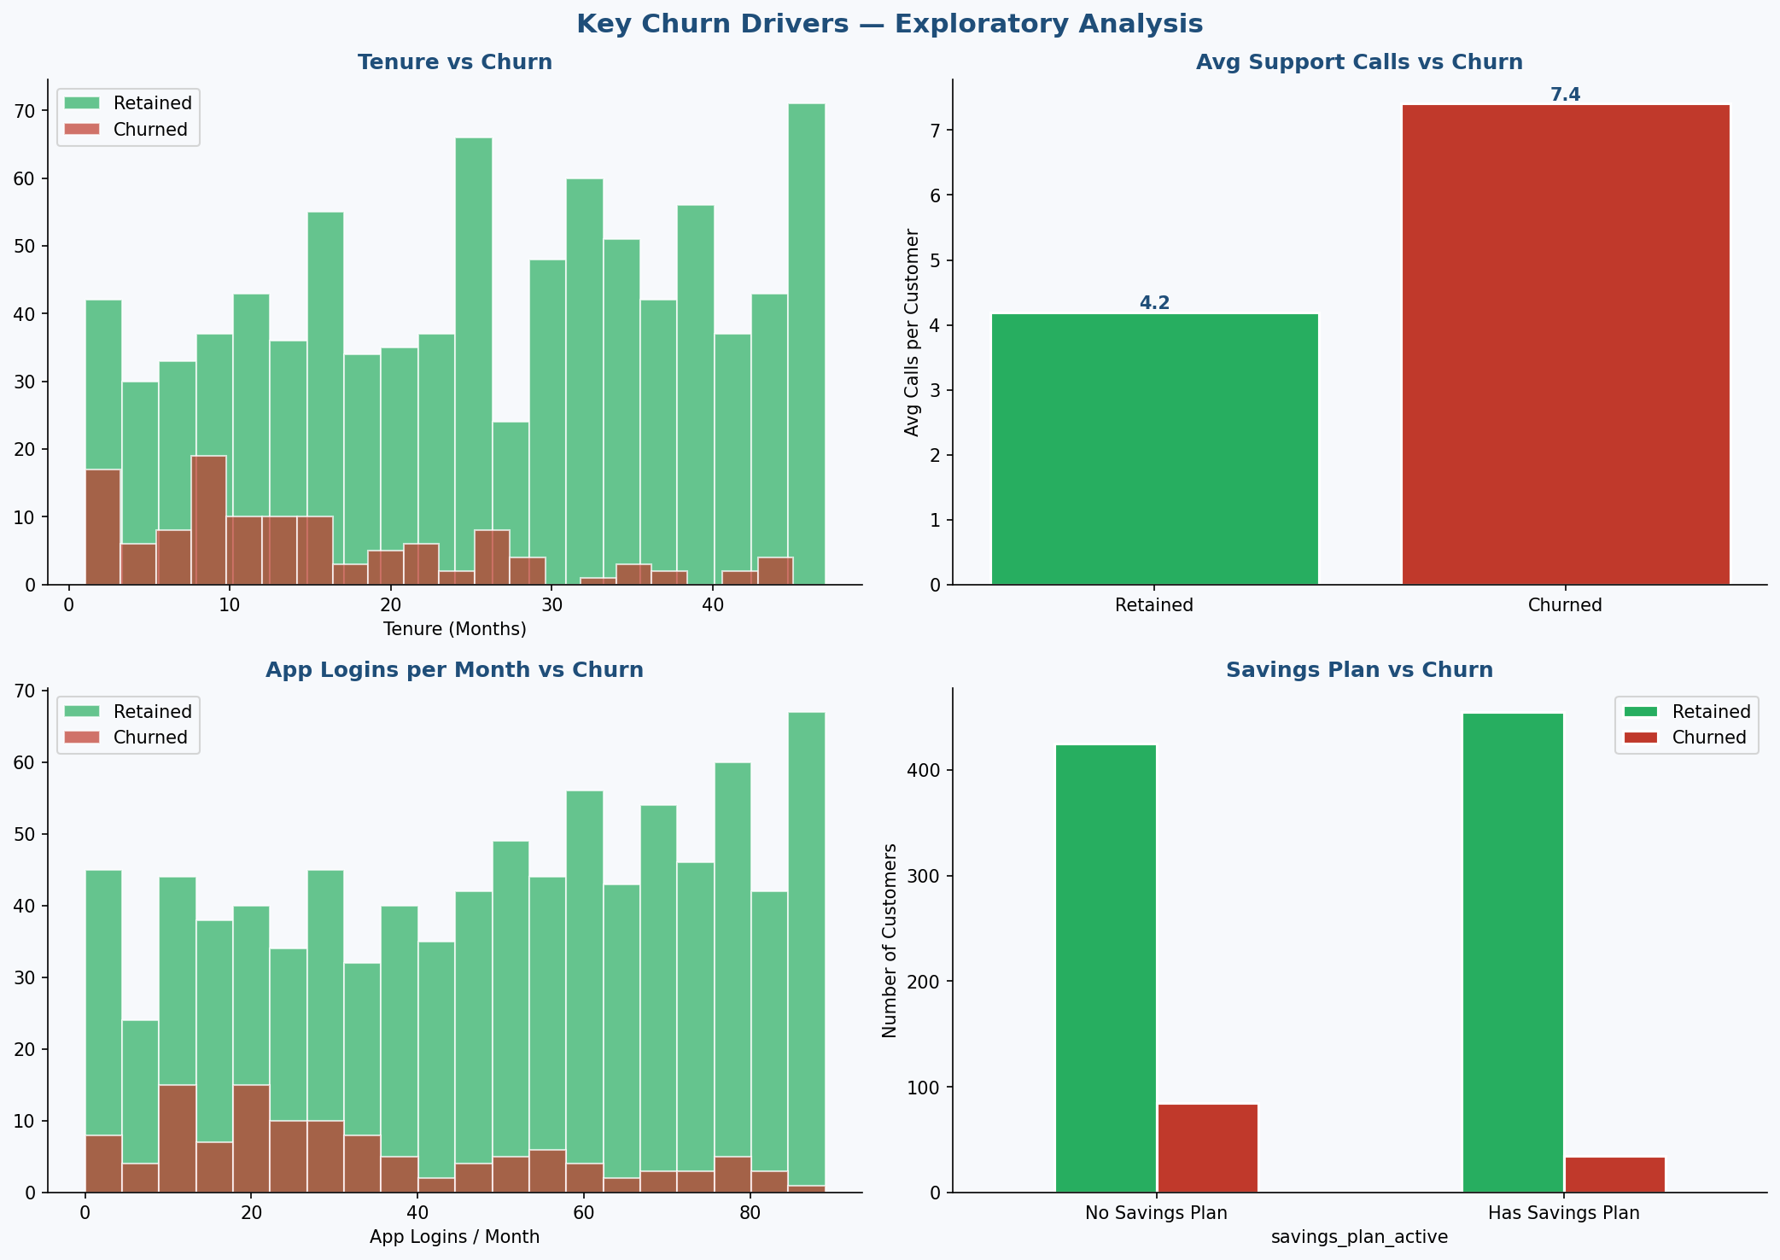
4. MACHINE LEARNING MODELS
4.1 Methodology
Two classification models were trained and evaluated on an 80/20 train-test split with class balancing to account for the imbalanced churn ratio:
- Logistic Regression — a robust, interpretable linear classifier well-suited to binary outcomes
- Decision Tree (max depth 5) — a non-linear model that captures interaction effects between features

Models were evaluated on Accuracy, Precision, Recall, F1-Score, and AUC-ROC — with AUC prioritised as the primary metric given the class imbalance.
4.2 Results
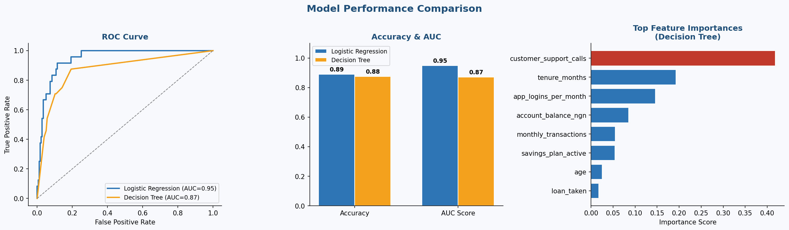

Model | Accuracy | AUC Score | Precision | Recall
Logistic Regression ✓ | 89.0% | 0.948 | 53% | 83%
Decision Tree | 87.5% | 0.871 | 49% | 71%

Logistic Regression outperformed the Decision Tree on AUC (0.948 vs 0.871), making it the recommended model for deployment. Its high recall of 83% means it catches 4 in every 5 churners — critical for proactive retention.
5. BUSINESS RECOMMENDATIONS
Based on the model findings, we recommend the following actions:

Early Tenure Intervention
New customers (0–6 months) are the highest-risk cohort. A structured onboarding programme with personalised check-ins during the first 90 days could significantly reduce early churn.
Savings Plan Activation Campaign
Customers with active savings plans churn at dramatically lower rates. Proactive in-app nudges encouraging savings plan adoption — particularly for Basic account holders — can serve as a low-cost retention tool.
Support Experience Improvement
High support call volume is a leading churn signal. Investing in faster resolution times and self-service support features (FAQ bots, in-app guides) can reduce frustration and pre-empt departures.
Engagement Re-activation
Low app login frequency precedes churn. Triggered push notifications for dormant users — personalised to transaction history — can re-engage at-risk customers before they leave.
Churn Risk Scoring in Production
The Logistic Regression model can be integrated into the company's data pipeline to generate a daily churn risk score for every active customer, enabling the customer success team to prioritise outreach.
6. ABOUT THIS PROJECT
This project was developed as a portfolio demonstration of applied data science skills in a Nigerian fintech context. The dataset was synthetically generated to reflect realistic customer behaviour patterns. All analysis was conducted in Python using Pandas, Scikit-learn, Matplotlib, and Seaborn.

I would welcome the opportunity to discuss how these techniques could be applied to real customer data to generate actionable retention insights for your team.

Ayodeji Toluwani | ayodejitoluwani@gmail.com | LinkedIn

